STUDENT ATTENDANCE STREAMING
Scala + Apache Spark Mini Project
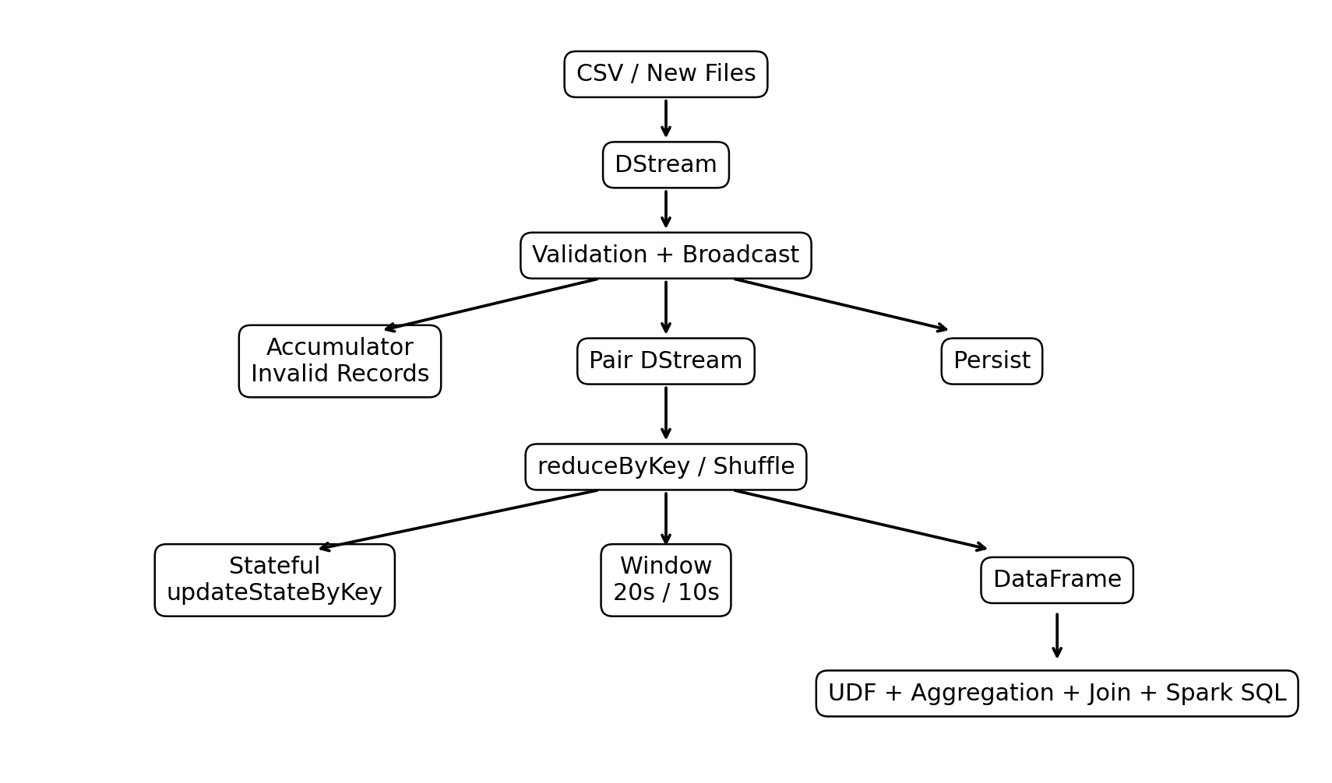

1. Project Overview
This project processes student attendance events using Scala and Apache Spark Streaming. Attendance records arrive as new CSV files in a streaming input directory. The application validates records, maintains state, detects repeated absences or late arrivals, performs window processing, and analyzes each micro-batch with Spark DataFrames and Spark SQL.

2. Objectives
- Process attendance data in streaming micro-batches.
- Validate incoming records and count invalid records.
- Use broadcast variables for common reference values.
- Use accumulators for data-quality/error counting.
- Demonstrate Pair DStream operations and reduceByKey.
- Maintain running counts with updateStateByKey.
- Detect repeated absences and late arrivals.
- Demonstrate sliding-window processing.
- Demonstrate persistence, repartition and coalesce.
- Use DataFrames, UDFs, aggregations, joins and Spark SQL.
- Explain DAG, stages, shuffle, partitions, lineage and fault tolerance.

3. Technologies
Technology | Version / Purpose
Scala | 2.12.18
Apache Spark | 3.5.3
Spark Streaming | DStreams
Spark SQL | DataFrame / SQL / UDF
SBT | Build tool
Java | 17
WSL2 | Linux environment

4. Input Schema
studentId, studentName, date, time, status
Valid statuses are Present, Absent and Late.

5. Architecture


6. Streaming and Validation
A StreamingContext uses a 5-second batch interval. textFileStream watches data/stream_input for new files. The CSV header is filtered. Each record is validated for five fields, non-empty required fields and a valid attendance status.

7. Broadcast Variable
The valid attendance status set is broadcast so worker tasks can access the same read-only reference efficiently.

8. Accumulator
A LongAccumulator named Invalid Attendance Records counts malformed or invalid attendance records. It is updated when a record fails validation.

9. Pair DStream and reduceByKey
Validated records are mapped to ((studentId, status), 1), then reduceByKey sums records for the same student/status key. reduceByKey is a wide transformation because matching keys can require a shuffle.

10. Stateful Processing
updateStateByKey maintains a running count across micro-batches. Checkpointing is configured at data/checkpoint because stateful streaming requires checkpoint metadata/state support.

11. Alerts
A student is reported when the running count for Absent or Late reaches at least 2. Example alerts include S005 with 2 Absent records, S007 with 2 Late records and S009 with 2 Absent records for the demonstrated data.

12. Window Processing
The application uses a 20-second window sliding every 10 seconds. This produces moving attendance counts over recent batches.

13. Persistence and Partitions
Validated attendance is persisted with MEMORY_ONLY because the same DStream feeds multiple downstream computations. A transform block demonstrates repartition(4) followed by coalesce(2). The demonstration is consumed with print so the partition code actually executes.

14. DataFrame and UDF
Each non-empty micro-batch is converted to a DataFrame. A UDF classifies Present as Regular, Late as Needs Attention and Absent as Critical.

15. Aggregations
Student-wise aggregation calculates presentCount, absentCount and lateCount. Overall aggregation counts each status. Department aggregation calculates total records and status counts after a left join with student reference data.

16. Join
Attendance records are left-joined with student department reference data using studentId. The joined output is then aggregated by department.

17. Spark SQL
The attendance DataFrame is registered as the temporary view attendance. SQL groups by studentId, studentName and status and calculates COUNT(*) as total.

18. Verified Output
For the demonstrated 15-record attendance data, the overall result is Present = 5, Absent = 5 and Late = 5. The department summary is ECE: 6 records (3 Present, 2 Absent, 1 Late); CSE: 5 (1, 3, 1); ME: 2 (0, 0, 2); EEE: 2 (1, 0, 1).

19. Narrow vs Wide Transformations
- Narrow: filter, map and flatMap.
- Wide: reduceByKey and repartition.
- Aggregations and joins may also introduce shuffle depending on the execution plan.

20. DAG, Stages and Shuffle
Spark builds a Directed Acyclic Graph from transformations. Narrow transformations can be pipelined. A shuffle redistributes data between partitions and commonly creates a stage boundary. reduceByKey is the main explicit shuffle example in this project.

21. Lineage and Fault Tolerance
Spark records transformation lineage. If a partition is lost, Spark can recompute it from the lineage. Stateful streaming additionally uses checkpointing at data/checkpoint.

22. YARN
The current demonstration runs in local[*] mode. In a cluster environment, Spark can be deployed with YARN, where the ResourceManager and NodeManagers coordinate cluster resources and Spark executors.

23. Output Folder
The completed application writes processed results under data/output. Expected result areas are attendance_categorized, student_summary, overall_attendance, joined_attendance, department_summary, sql_result, window_counts and alerts. Spark CSV output directories contain part files and _SUCCESS.

24. Test Cases
- Normal attendance batch: validates normal processing.
- State test: verifies running counts across batches.
- Alert test: verifies repeated absence/late alerts.
- Window test: verifies 20-second sliding window.
- Invalid test: verifies validation and accumulator.
- Final real-name batch: verifies complete DataFrame, UDF, aggregation, join and SQL output.

25. Run Commands
cd ~/student-attendance-streaming
sbt clean compile
sbt run
While sbt run is active, open a second terminal and create a NEW CSV file in data/stream_input. Wait for the next 5-second micro-batch.

26. Conclusion
The project provides an end-to-end demonstration of Spark Streaming and Spark SQL using Scala. It combines real-time file-based streaming, validation, stateful processing, alerts, windows, RDD concepts, persistence, partition management, DataFrames, UDFs, joins, aggregations and SQL. The final output can be displayed in the terminal and persisted under data/output for inspection and demonstration.

27. Final Demonstration Checklist
- Compile successfully.
- Start the streaming application.
- Add a new CSV file while the application is running.
- Verify Attendance DataFrame output.
- Verify UDF output.
- Verify Student Summary.
- Verify Overall Attendance.
- Verify Join Result.
- Verify Department Summary.
- Verify Spark SQL Result.
- Verify Invalid Records count.
- Verify repeated absence/late alerts.
- Verify window output.
- Verify data/output directories.
- Capture final screenshots for submission.

28. Execution Evidence / Screenshots
The following screenshots were captured from the completed Spark Streaming run. They demonstrate the real-name attendance input and the resulting DataFrame, UDF, student aggregation, overall aggregation, join, department aggregation and Spark SQL outputs.

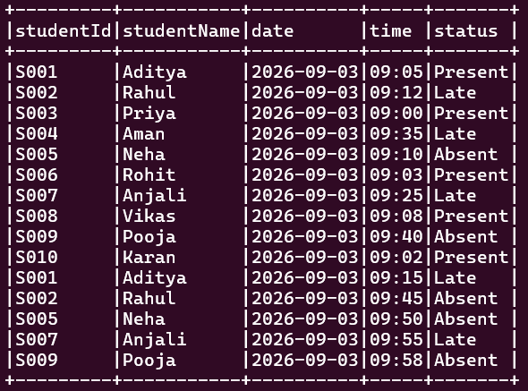
Attendance Dataframe

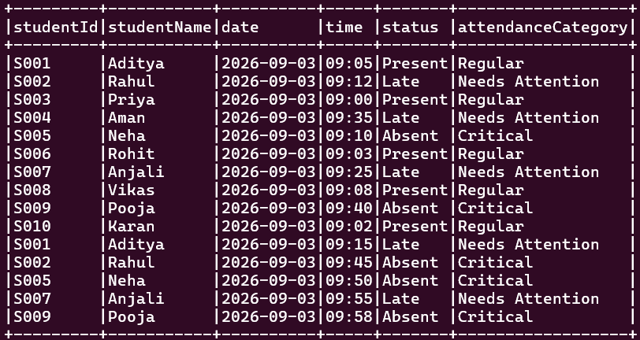
UDF Result

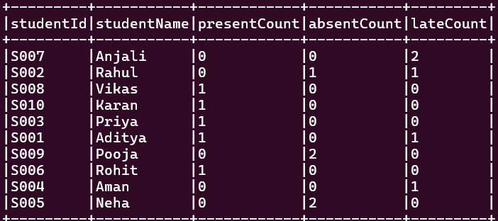
Student Summary

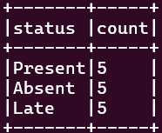
Overall Attendance

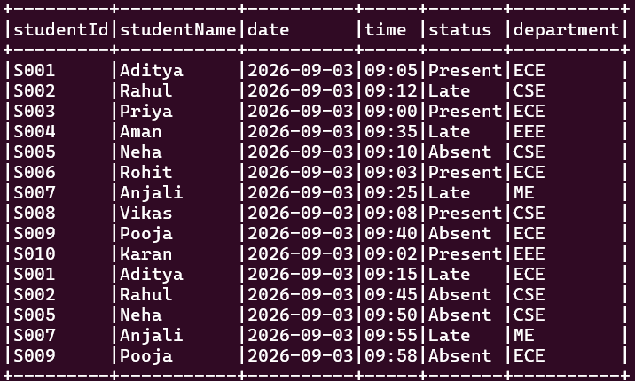
Join Result

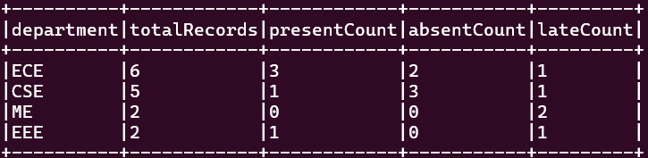
Department Summary

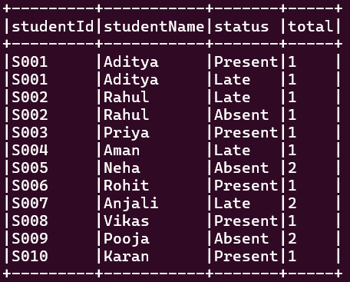
Spark SQL Result

